Tasks for Sprint 1: Account Creation and Profile Page

Github: https://github.com/Sylnus/Personal-Finance-Tracking-App/tree/main

Account Creation Page + Sign In:

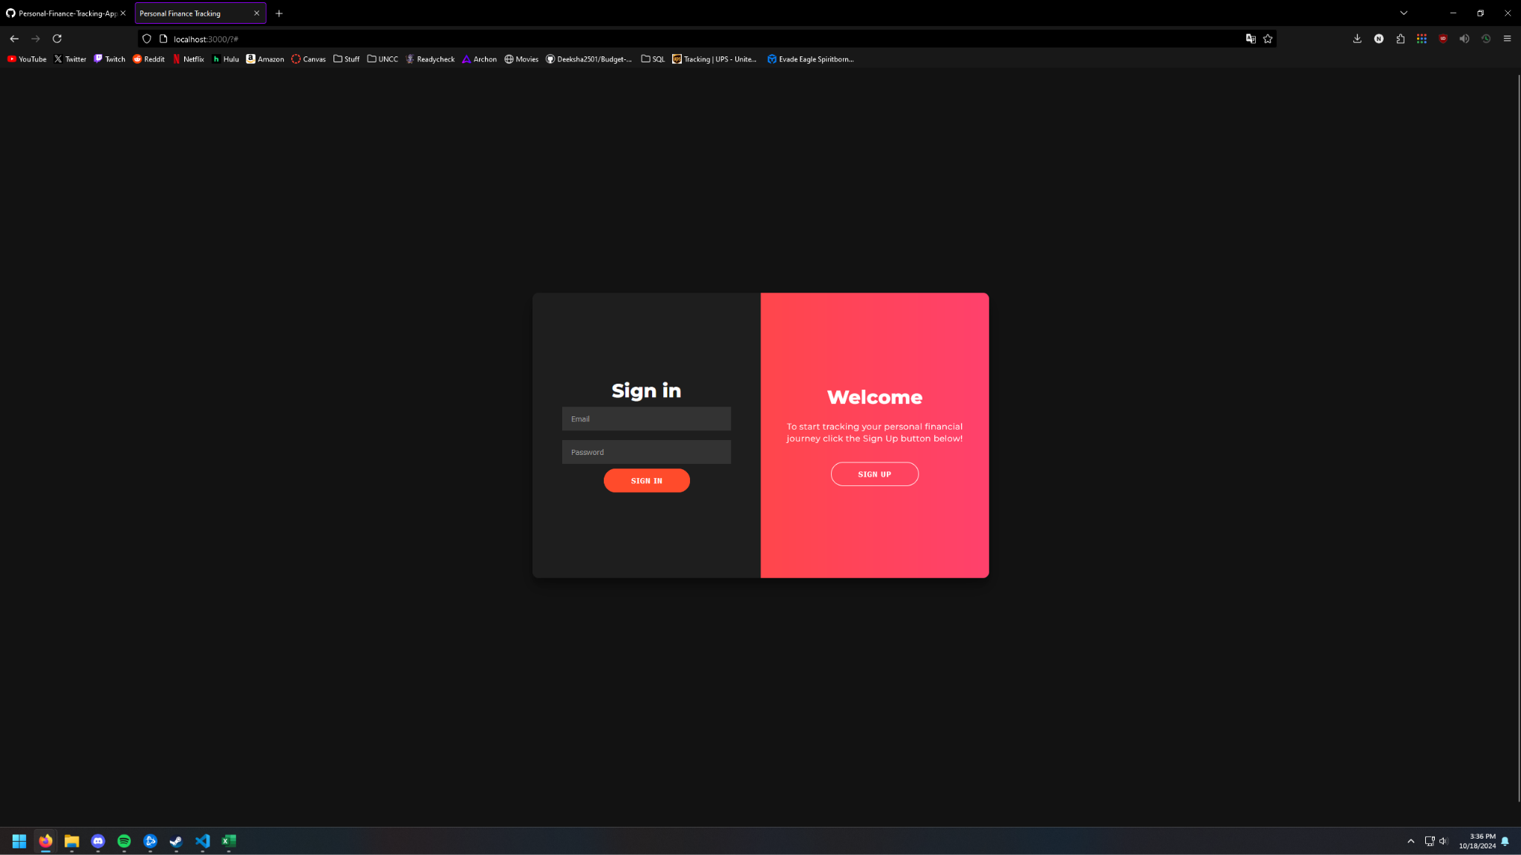

Account Settings page based on the user sign up info:

Profile Page after user adds additional account information using the form:

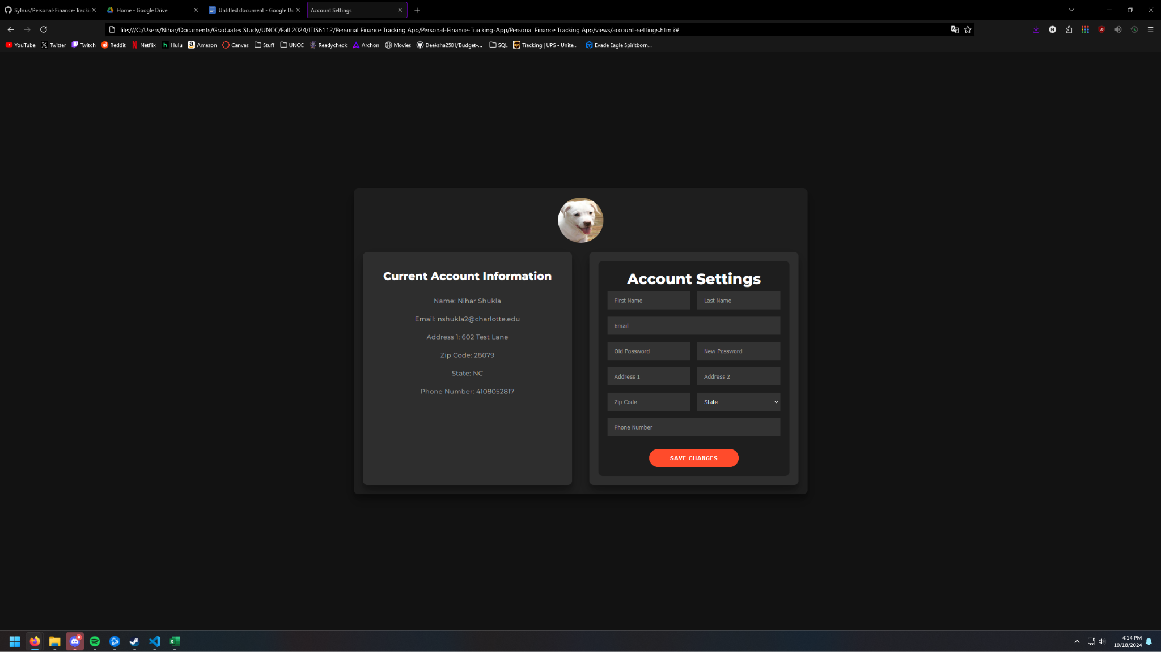

Post sign up/sign in landing page:

